2023 Pageant Rules and INFo
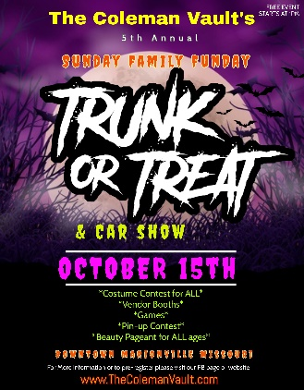
Thank you so much for joining us this year! We hope everyone has a wonderful time and remembers this is all in the name of fun.
Homework Tips Checklist for Parents

Registration
☐ Forms: Registration forms can be found on our Facebook Event page. You may also request a form by calling or texting 417.229.0167. Forms may be printed off or completed online but editing our original content is prohibited and will not be accepted. You may turn in your registration in person @ The Aloha Senior Apartments located at 111 W. Springfield Street, Aurora MO 65605, send it to the Coleman Vault’s Facebook Page, or you may also email aha.valk@yahoo.com. Please note no registration will be complete without confirmation. Only 10 contestants will be permitted per division. Forms must be turned in by Fri. Sept 29th
☐ Entry Fees- A NON-REFUNDABLE $25 Entry fee is due at time of registration. This can be paid in a variety of ways including in person at the address mentioned above, by requesting an electronic invoice through our square app, or by VENMO @TheColemanVault. If paying thru VENMO we MUST be notified and contestant names must be noted on payment.

Pageant Rules and Expectations
☐ Attire: Although our pageant is Halloween Themed, our contestants must approach it like any other pageant as to dress in their Sunday’s Best or formal modestly with NO props, corsages, or anything to be carried in hands. Contestants are however, encouraged to wear popular Halloween colors or patterns if they wish to do so. Age-appropriate hair and make-up is expected. The following are recommendations:
☐ Neckline to be cut in a modest way to avoid showing cleavage
☐ Dresses should be longer than mid-thigh and should not be excessively tight
☐ Space between 2-piece dresses is less than 2 inches (not showing of the navel)
☐ Slits in skirts or dresses should not be higher than 3 inches above knee

☐ Peoples Choice: Contestants are encouraged to pursue sponsors as well as supporters as the “People’s Choice” award will be $1 per vote and the winner shall receive a goodie bag totaling over $200 in retail value. Each Contestant will have a box marked with their contestant number as well as division for public voting at the table with the judges. Boxes must remain on the table at all times.

☐ Rehearsal: Because of the pageant facility being a rental location, rehearsal will be shown virtually on our FB Event page, but can also be received via email or on FB messenger the week of the pageant.

Winners
☐ All contestants will receive a goodie bag for participating
☐ Winner, 1st & 2nd Runner up shall receive Crowns, Sashes, & Trophies as well as additional goody bags
☐ Winners will be asked to act as our “Ambassadors” during our Trunk or Treat Event the following Sunday if available where they can hand out trophies and awards to our car show, pin-up or costume winners if they are not participating their selves. (Winners are MORE than welcome to enter those contests as well) We are not responsible for minors; an adult must be present at all times.

Sunday Oct 1st @ 2pm,

Marionville Elementary Gym

(formally High School Gym)

